To Whom it May Concern,

Effective July 1st, 2022, The Georgia Tech Foundation Accounts Payable team will be issuing both individual reimbursements and vendor payments solely through ACH. Please fill out the banking information below for the receiving party.

Business / Individual Name: Click or tap here to enter text.

Remittance e-mail: Click or tap here to enter text.

Bank Name: Click or tap here to enter text.

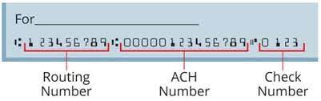
Bank Routing Number*: Click or tap here to enter text.

Bank Account Number: Click or tap here to enter text.

*DISCLAIMER: please note that the routing number provided on a check may be different than an ACH remittance routing number. Please review with your bank to ensure accurate ACH information.

I, Print Name, acknowledge that the above information is correct.

Please return this form to gtfap@gtf.gatech.edu and note any concerns. We ask for patience during this time as this is a brand-new process.

Sincerely,

Georgia Tech Foundation Accounts Payable

Robert Langston: 404-894-6132
Julie Trube: 404-894-6130
Georgia Davidson: 404-894-6131

